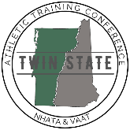
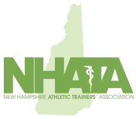
New Hampshire Athletic Trainers’ Association
Continuing Education
Speaker Release Form

The New Hampshire Athletic Trainers’ Association may make 2024 Twin State Athletic Training Conference presentations available to participants through audio, video, and print. We request your permission to duplicate, distribute and/or perform the presentation which you deliver at the upcoming session.

As an invited speaker, please complete the agreement below and return to New Hampshire Athletic Trainers’ Association at P.O. Box 438, Grantham, NH 03753 or through email to ceus@nhata.org.

Speaker Information
Name:
Title:
Institution:
Address:
Email:
Telephone
Presentation Information
Presentation title:
Program title: | 2024 Twin State Athletic Training Conference
Date(s): | June 10 and 11, 2024 Online though July 11, 2024
Location: | St. Paul’s School – Concord, NH

I agree to participate as a speaker in the 2024 Twin State Athletic Training Conference
I grant the NHATA the right to use my name, voice and presentation content.
I warrant that my presentation and any material(s) I submit do not infringe on the rights of others.
I agree to obtain such permission(s) from the copyright owner(s) should my presentation or the material(s) I use during or in connection with my presentation require permission for use.
I agree to inform any material co-authors of this presentation and obtain such permissions as needed.
I grant the NHATA permission to distribute recordings, videos or resources.
I understand that execution of this Agreement does not obligate the NHATA to publish my presentation or the materials used therein.
I verify that I am the author of this presentation, I have authority to enter into this agreement and that I will be bound by its terms.
I agree to disclose the presence of conflicts of interest associated with my presentation in writing to the NHATA and within my presentation to attendees.

Speaker name (print):
Speaker name (sign):
Date:

